Dilarom F. Kuchkarova,
ScD, professor;

Dilnoza A. Achilova,
ScD student,
Tashkent Institute of Irrigation and
Agricultural Mechanization Engineers

Level and Structure Assessment of Student’s Knowledge in Engineering Graphics

Key words: concept, activity projection, qualimetric assessment, quality of training, complexity and difficulty of assignments.

Annotation: the article discusses approaches to diagnosing the level and structure of students' knowledge of engineering graphics on the basis of the developed methodical suggestions. For determine the level of knowledge of a particular student the quantitative indicators are proposed.

Modern requirements of a specialist stipulate introduction into educational process of technologies, based on activity projection of an instructor and a student.
The following components are supposed here: 1. hierarchy of educational purposes; 2. structural educational information to be learnt; 3. programme for knowledge activity of students and management and control as well; 4. the instructor activity program on the base of system optimization of educational forms and methods.
Two approaches are possible: the first approach is empirical, based on analysis of complicated activity kinds and on the alternative of corresponding ways of solving educational tasks in concrete situation; the second approach uses planning method with application of algorithm coordination and intercommunication of activity kinds in educational process.
The second approach allows to work out the base programme of skills and knowledge to form all activity kinds in the framework of educational discipline.
Such approach gives an opportunity to construct the educational preliminary model process, formed on the basis of a specialist activity analysis.
It should be noted the main development trends of modern higher education covering all the levels. First, it is the education diversification that shows the important volume expansion of its content and introduction of new training methods. Second, educational internationalization requires securing of total educational space, preserving national traditions. Third, competent approach is an innovation in interpretation of education results quality.
On the basis of educational process model there is a competence model of specialists’ preparation, including combined quality data and assessment methods. In the higher education system, the following quality characteristics are provided: potential quality of obtaining education purpose, process quality of professionalism formation and quality of education results.
Education results quality is understood as an integral characteristic, reflecting the corresponding degree of obtained results to normative and personal expectation of students (1).
In up-to-date pedagogical science the dynamic approach has been obtained in interpretation of education results quality, where quality is implied as positive changes in educational processes, as data of creative activity, obtained knowledge and skills or other education achievements of students during total training period (2).
In dynamic approach the training results assessment is being made while conducting analysis of many factor changes in the line of good progress, that shows tendencies for quality changes and their prognosis. In modern understanding of education quality it is supposed fruitful combination of competent and dynamic approaches allowing to formulate adequate demands to the quality.
In system of higher technical education engineering graphics takes particular place as discipline and founds base for professional training of engineers. Just that discipline is directly and indirectly linked with all engineering professions and forms technical skillfulness during training. The level of technical skillfulness directly depends on knowledge of engineering graphics and ability to operate graphics and skills in computer graphics packages.
In previous articles authors considered problems of factors’ interaction that have influence on successful engineering graphics training, on qualimetric assessment of students and upon engineering graphics training quality management (3,4)
The purpose of this article is to work out quality indexes of level and structure of students’ knowledge in engineering graphics based on assignment classification to a certain degree of difficulty and complexity.
The necessary quality achievements in the process formulating professionalism and in training results suppose availability of effective project mechanism of an instructor and a student activity (that has been mentioned at the beginning of this article) and qualimetric assessment of this activity.
In special literature on higher education qualimetrics the notion “quality measures” is introduced which is interpreted as a part of mathematic formalism in theory of quality and is connected with development of measurement tools (1). Qualimetric monitoring of level and structure of students’ training may be based on well-known hierarchy (2): 1.the minimum level of knowledge i.e. formation of threshold commences knowledge which is necessary for comprehension of discipline basys.2.the level of standard main programme knowledge. 3. the level of programme knowledge (non-standard). 4. the level of over programme knowledge.
In skill system the following hierarchy levels are shown [5] 1st level – formation of elementary based reproduction skill, based on repetition of one well--determined action; 2nd level- algorithmic level of skill formation, based on sound mastering of algorithmic activity while solving standard tasks; 3rd level – analytical level of skill formation, based on analysis of available skills application , which provides guarantee in solving tasks; 4th level – many functional skill level formation, based on combined skills in solving various tasks; 5th level- creative level of skill formation, based on evristic skill application for producing new skills in solving non-standard tasks.

The level of knowledge and skills considerably depends on personal efforts and ability of students while knowledge structure considerably depends on educational process arrangement.
Engineering graphics specificity, as a training discipline, is determined with the necessity to operate with graphic images, to develop space imagination and thinking. In previous articles the authors mention that space imagination and thinking are not connected with total student preparation and can be natural abilities and acquired characteristics as well.
The mentioned above specificity requires classification of assignments according to difficulty and complexity to a certain degree while appraising the level and structure of students’ knowledge. If complexity is connected with quantity of intellectual operations, that are necessary to be done in solving assignments process, then difficulty determined with the time necessary for solving them (6).
In special literature complexity and difficulty are assessed by concept quantity that are necessary to solve assignments and by the way of thinking over these assignments (6).
Under the concept some intellectual conclusion is implied (formula, rule, provision and so on) allowing to approximate the right decision.
Let’s divide complexity engineering graphics assignments into 4 conditional groups according to necessary knowledge levels:
Level 1 – it is the choice of one answer variant using one concept. The knowledge of names, determinations are necessary here.
Level 2- it is applicability of learnt knowledge in typical situations, of skills to reproduce copies with the help of some concepts; thinking is connected with saying views of conjunctive and disjunctive kinds;
Level 3 - it is applicability of learnt knowledge and skills in typical complicated situations, requiring application of several concepts and their combinations. Thinking is connected with associations, classification and reasonable and effective expressions.
Level 4 – applicability of learnt knowledge and skills in non-standard conditions, earlier unknown to a student, requiring concept combinations, arguing of deductive and inductive character, conclusions and analogy.
For example, assignments A and B are referred to the second level of complexity; they suppose rule knowledge of conjugated angles and arcs, but assignment B is more difficult as it requires more period to complete it (operations of the same type to draw a circumference)
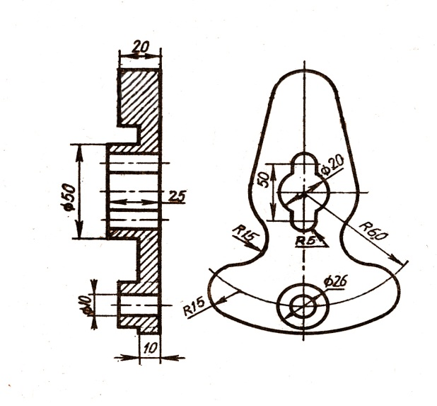 AB
Fig. 1.
Let’s give assessment 1 to the first assignment level, to the second assignment -2, to the third assignment -3, to the fourth assignment -4. Assessment product 1* 2* 3* 4* gives maximum index of knowledge level of “ideal’ student. In practice maximum index is hardly achievable.
Let’s mark the number of gaps in knowledge of the first level students as X1.
Every gap in knowledge obtains quantitative mark 0,1. Drawing 2 has the first level assignment that requires knowledge of view fulfillment to solve the task, i.e. one concept.
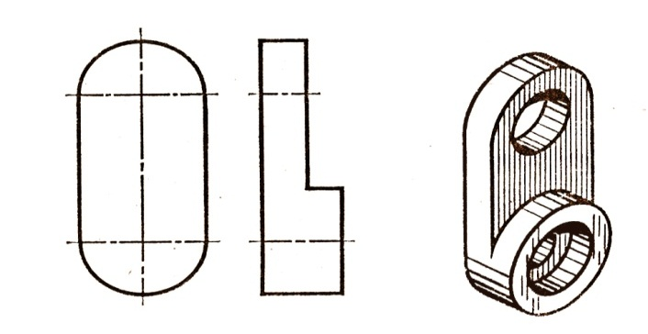
Fig. 2 Level 1 assignment.
While performing the assignment the student can make the following mistakes: removal of centers in holes, wrong size determination, wrong width of lines and so on., then the student gets assessment [1-X1] for the first level assignment. Having three gaps in his/her knowledge he/she will get assessment (1-0,1*3)=(1-0,3)=0,7.
Let’s mark X2 the number of gaps in knowledge of the second level students. For example, drawing 3 has the second level assignment.
To perform this assignment it is necessary to know the rules of various lines conjugation, how to divide circumference into parts and how to indicate sizes. In case of making mistakes this student gets assessment (2-X2) for the second level task.
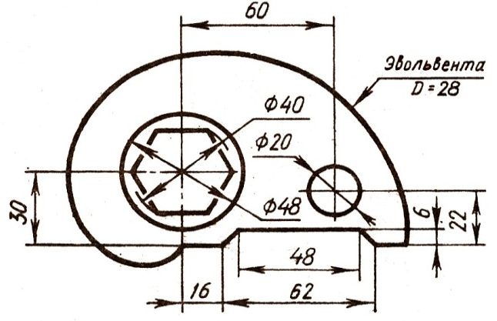
Fig. 3 Level 2 assignment.
Let’s mark X3 the number of gaps in knowledge of the third level students.
For example, number 4 drawing has an assignment of the third level. To perform the assignment it is necessary to know rules of layout kinds, turning of the hatching part in parallel to the front surface of projection, the image of polyhedrons and curved bodies and also thinkable operations of object displacement. In case of making mistakes the student obtains assessment (3 – X3) for the third level task.
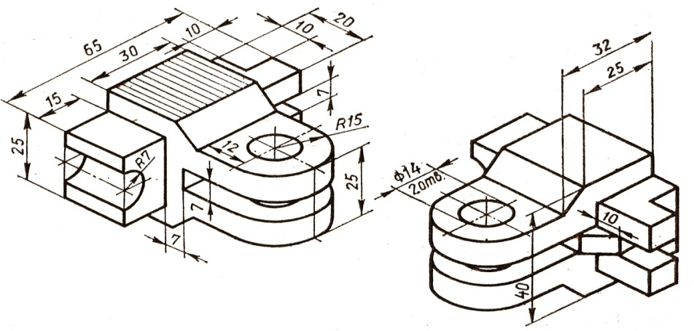
Fig. 4. Level 3 assignment.
Let’s mark X4 a number of gaps in knowledge of the fourth level students.
For example, drawing 5 has the fourth level assignment and requires knowledge of the whole course of projection drawing for right combination of view halves and cross-sections, and also thinkable conjunctive and disjunctive operations.
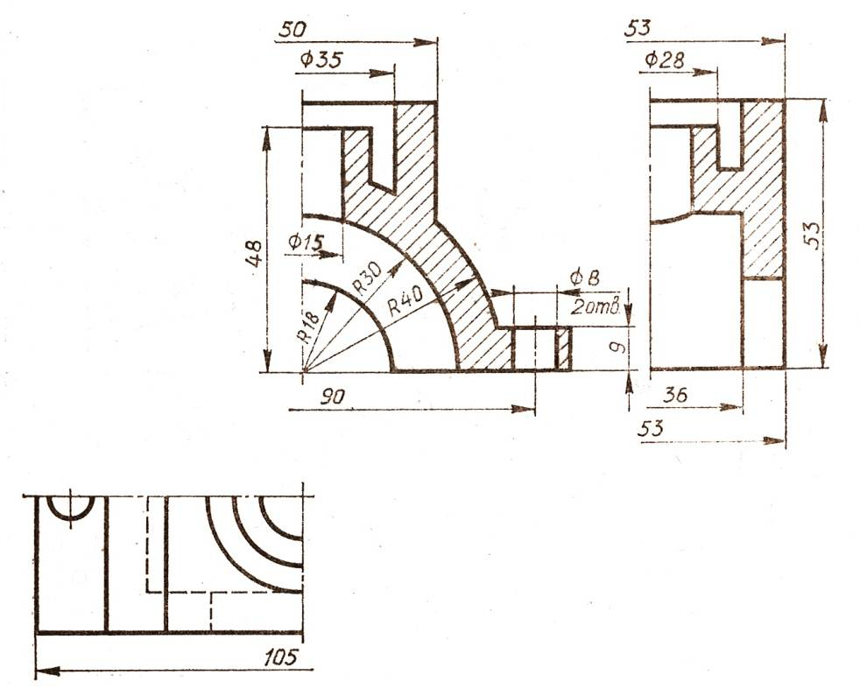
Fig. 5. Level 4 assignment.
Like in previous cases, a student obtains assessment (4 – X4) for assignment of level four.
Multiplicative function F=(1-X1)*(2-X2)*(3-X3)*(4-X4)<24 determines the final assessment of knowledge level and structure of certain student.
Assessment is being changed during the total education period and is a dynamic component of qualimetric student assessment.
References:
- Subetto AI. Education Qualitology. St. Peterburg, 2000; 132.
- Zvonnikov V., Chelishkova MB. Training Quality Control during Certification. Competence Approach: Tutorial. Moscow, 2009; 224.
- Kuchkarova DF, Achilova DA. Education quality control in process of
- Engineering Graphics Training: Pedagogics, N 5, 2015; 105-108.
- Kuchkarova DF, Achilova DA Qualimetric assessment of Higher Education Institution students: Pedagogics, N 4, 2016; 128-132.
- Shikhov UA. Projecting and realization of complex qualimetric monitoring
- of students’ preparing in system “profile school- higher technical education institution: Thesis for doctor’s degree of technical science. Izhevsk, 2008; 320.

